Operating Systems Lab Assignment 4 –
Task 1: Batch Processing Simulation
Write a Python script to execute multiple .py files sequentially, mimicking batch processing.
Sol. -
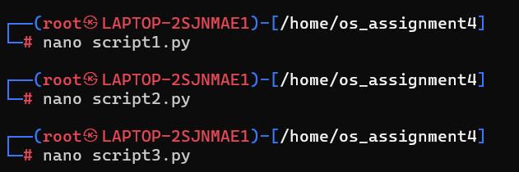
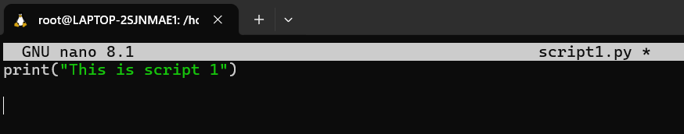
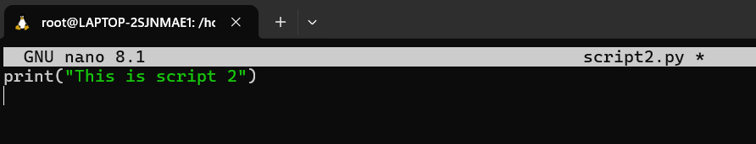
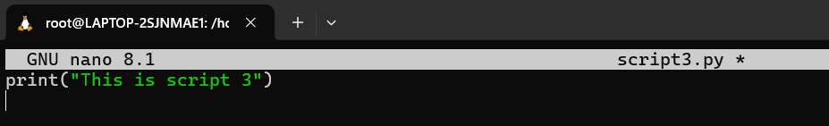
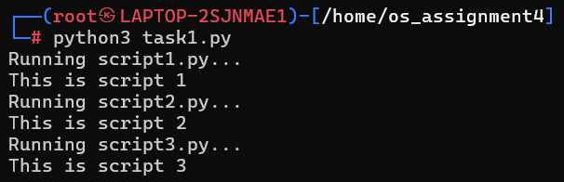

Task 2: System Startup and Logging
Simulate system startup using Python by creating multiple processes and logging their start and end into a log file.
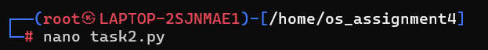
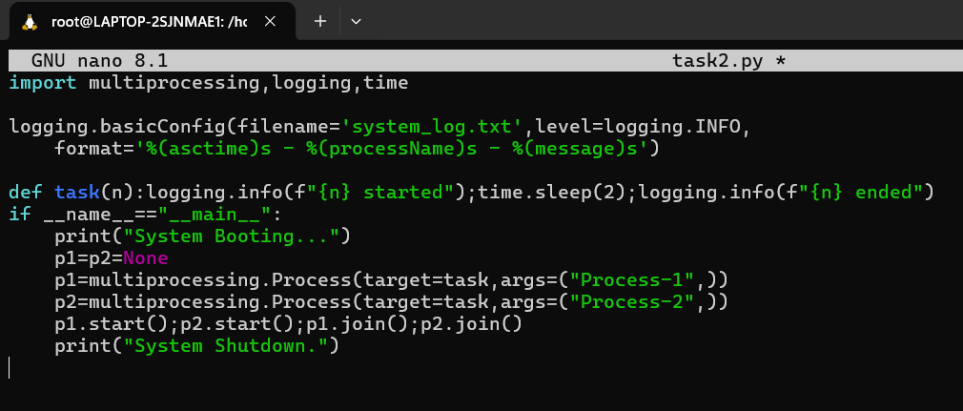
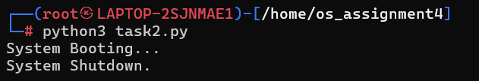

Task 3: System Calls and IPC (Python - fork, exec, pipe)
Use system calls (fork(), exec(), wait()) and implement basic Inter-Process Communication using pipes in C or Python.
Sol.-
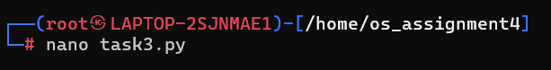
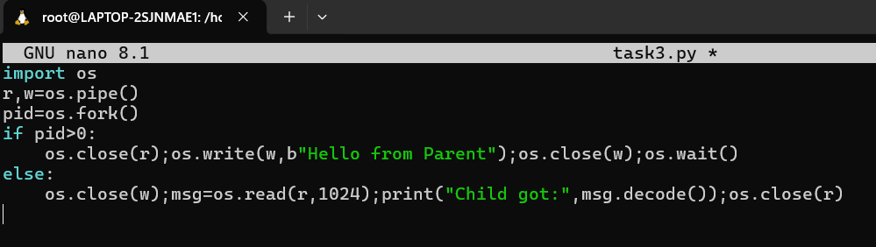
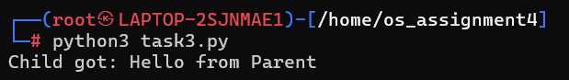

Task 4: VM Detection and Shell Interaction
Create a shell script to print system details and a Python script to detect if the system is running inside a virtual machine.
Sol.-
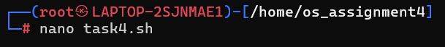
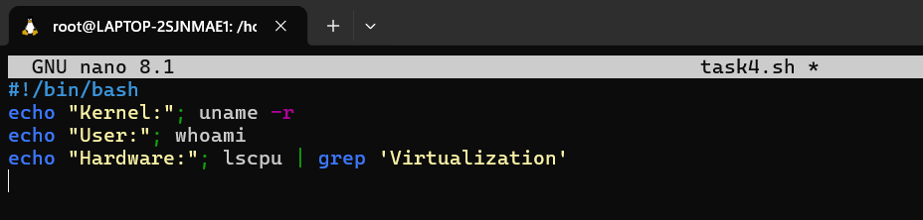

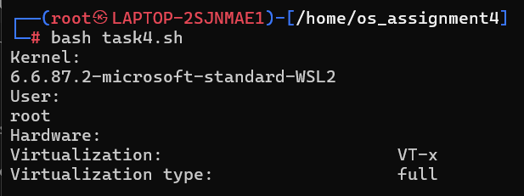
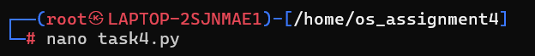
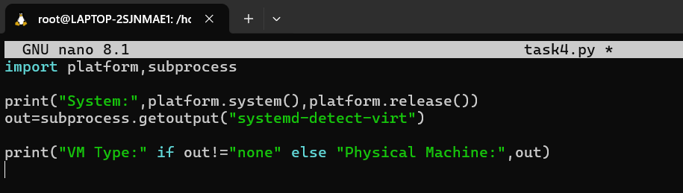
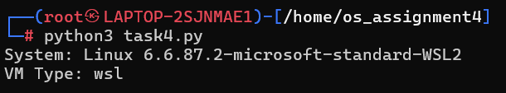

Task 5: CPU Scheduling Algorithms
Implement FCFS, SJF, Round Robin, and Priority Scheduling algorithms in Python to calculate WT and TAT.
Sol.-
